REPORT FOR: | HEALTH AND WELLBEING BOARD
Date of Meeting: | 7th June 2018
Subject: | INFORMATION REPORT – Annual Public Health Report
Responsible Officer: | Carole Furlong, Director of Public Health
Exempt: | No
Wards affected: | All
Enclosures: | Child poverty and Health Inequalities Strategy

Section 1 – Summary

This report gives an update of the Child poverty and health inequalities strategy. The report summarises some of the key priorities and actions that the council have taken to mitigate the effects of poverty in the borough, looks at what the most recent statistics say and what it means for us in Harrow

FOR INFORMATION

Section 2 – Report

Public health presented the report on Child poverty at the Health and Wellbeing board in 2016. We committed to developing a child poverty strategy and action plan for Harrow. We engaged with key local partners in the statutory and the voluntary / community sector were invited to agree what we need do to mitigate child poverty and ensure that every child in Harrow has the best opportunity to meet and fulfil their full potential. This report re-visits the priorities set out for Harrow and progress on the strategy and action plan. The report will highlight some of the key actions and activities since the strategy was written.

Child poverty landscape:

Recent figures show that child poverty still persists in Harrow with higher numbers in poverty after housing costs (AHC). The average number of children in poverty in Harrow before housing costs (BHC) is 11,606 (20.70%). The number of children in poverty AHC goes up to 17,769 (31.69%), shown in the graph below.

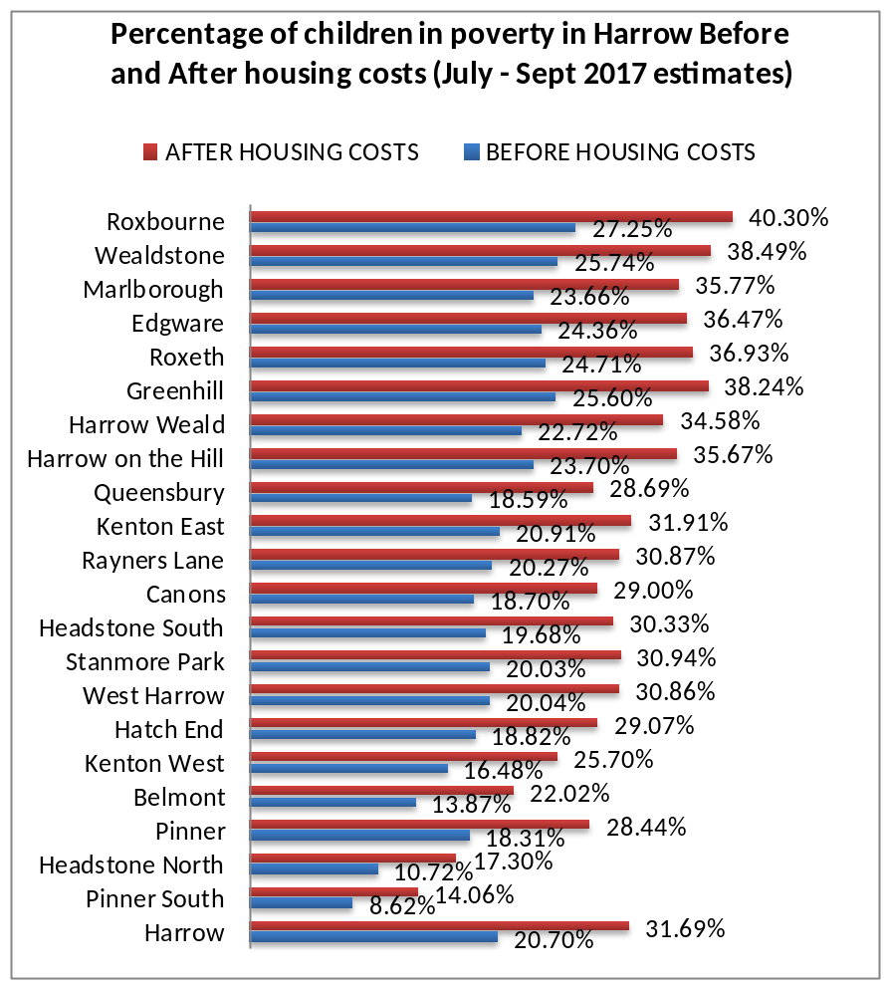

Child poverty levels are highest in Roxbourne with 1,018 (27.255) BHC, and this rises to 1,505 (40.30%) AHC. This is a stark difference when compared to wards like Pinner South where the levels of child poverty are much lower 201 (8.62%) BHC and 328 (14.06%) AHC.

Child poverty persists as a concern nationally as evidence suggests that the number of children in relative low income households will increase sharply between 2015/16 and 2021/22 (Institute of Fiscal Studies) and for a borough like Harrow it will be even more stark for wards such as Roxbourne, Wealdstone and Marlborough where child poverty levels are highest.

Evidence from the child poverty needs assessment we completed in 2016 shows that worklessness, unemployment, low incomes, high living and housing costs, low parental skills, poor health and educational attainment all contribute to higher child poverty rates. Harrow’s approach to tackling poverty addresses these issues.

The vision for Harrow is “To support children and their families’ break the cycle of poverty and deprivation in order to thrive live safe, happy, healthy and lead successful fulfilling lives” (Harrow child poverty and life chances strategy 2017-2020). This vision is underpinned by the 5 agreed priorities:

- Priority 1: To increase opportunities for parents with English as a second language to enter employment, education and training and support adults in gaining skills
- Priority 2: To tackle financial exclusion, including debt management, financial literacy, affordable credit and maximise benefit take up.
- Priority 3: To increase opportunities for inward investment and funding opportunities by working
- Priority 4: To improving health and wellbeing of all children and families and access early support services with a focus on looked after children, children at the edge of care, children with Special Educational Needs and Disabilities (SEND)
- Priority 5: Support families with housing and those in temporary accommodation

Key actions are monitored by the child poverty group including colleagues from economic development, housing, early years, children’s centres, voluntary and community sector and support from the child poverty action group (CPAG) and are in contact every 6 months and meet annually. The next meeting is in June 2018 where we will be refreshing the action plan.

Since the strategy and action plan were written, we have been able to influence a number of bids and applications for funding. The strategy has been referenced and has helped with a number of applications for funding for example an application to Health Education North West London (HENWL), totalling £64,000 to deliver health related projects targeting some of the most vulnerable people in the borough. Some key actions and activities are outlined below:

Public health

Despite the huge cuts to the public health service in Harrow we are continuing to address improving health outcomes for children and young people. Our three key commissioned services including, the Harrow Substance misuse service, Sexual health service and Health visiting and school nursing (0-19 provider to begin service on 1st July 2018) all support families in the borough to improve their health and wellbeing.

The Harrow Substance Misuse Service is tailored for both young people and adults. The role of specialist substance misuse services is to support young people and adults to address their alcohol and drug use, reduce the harm caused by it and prevent it from becoming a greater problem.

Harrow Young People’s substance Misuse Service is delivered by Compass. Young people can enter specialist substance misuse services with a range of problems or vulnerabilities relating to their substance misuse. Our Provider delivers an outward looking model to strengthen mainstream services and deal with lower level issues rather than meet all drug and alcohol related needs in-house. Special attention is given to Young People who have wider vulnerabilities and to enable greater engagement. There has been a significant increase in referrals from universal and alternative education in 2017/18 which outweighs referrals from the Youth Offending Team. This trend is potentially positive as it suggests young people are increasingly able to receive appropriate substance misuse interventions at an earlier stage.

Harrow Adult Substance Misuse Service is delivered by WDP. Our Provider WDP has a strong partnership with the local authority Children and Family Services and are co-located at the respective teams via a Hidden Harm Worker. The role of the Hidden Harm worker is to identify and support parents/carers who are involved in problematic drug and/or alcohol misuse and to minimise the impact on their children. This role also contributes to coordinating integrated care plans, communicating between teams and transparency with parents about joint aims of treatment.

As part of the newly commissioned 0-19 Health Visiting and School nursing we are introducing more checks for the most vulnerable at 4-5 months and 3.5-4.5 years, along with vision screening for reception age pupils. There will be an increased frequency of visits by school nurses to schools. The service will be focussing on oral health, healthy weight and school readiness.

Public health have actively supported schools and early years settings through the Mayors Healthy Schools London awards. Harrow have achieved 11 Gold, 16 Silver and 32 Bronze Healthy School London awards which means that schools are actively working towards improving physical activity, healthy eating and emotional wellbeing of the children at their school. Norbury School, a HSL Gold award achiever for 2017, has been invited to present at the prestigious HSL award ceremony at the GLA to present the work they are doing on Female Genital Mutilation.

Housing and Homelessness

The economic development team continue to give ongoing support to homeless families and those in temporary accommodation. The team support households to increase their income and manage debts, become more digitally included and reduce rent arrears. Tenants also receive floating support if they require it. The team give money advice/money management sessions and will continue to offer these sessions to households that need it. Housing continue run sessions such as Get Online/My Computer sessions in partnership with Xcite and Learn In Harrow. Information on money advice and welfare reform is provided on the housing website/portal and in the Homing In magazine that goes out to social housing residents.

There is a working group on Universal Credit to help the Housing department and tenants to get ready for the change. Housing bought in a specialist magazine for tenants on Universal Credit to give out at the residents meeting and also to a targeted group likely to be affected by UC first. Housing are also developing a digital and financial inclusion strategy for the department.

Economic regeneration and employment support

Harrow is benefiting from a £1.75Bn regeneration investment, primarily into the Heart of Harrow Opportunity area. The programme is delivering 5,500 new homes, two new schools, around 3,000 new jobs. The Regeneration Strategy sets out our objectives to ensure economic benefits for our Communities and Business – by creating opportunities for local businesses, building local supply chains, tackling skills deficiencies and maximising local recruitment.

The Cabinet Report on Social Value in Procurement has led to £57m being spent with local businesses and the employment of residents and creation of apprenticeships on council contracts. The council’s Xcite programme provides a range of employment services to help workless residents into sustainable employment, and its Learn Harrow service delivers a range of family learning and functional skills teaching to improve the employability of parents. The Xcite team have been successful in securing funding from the flexible support fund from Jobcentre plus to support lone parents into work. In the last financial year over 300 residents were supported into work by Xcite and Learn Harrow.

Section 3 – Further Information

With the public health team being reduced significantly, the number of projects aimed at improving health and wellbeing will also be impacted. Public health will continue to monitor child poverty levels in Harrow and work closely with key partners and cross departmentally to capture some of the actions going forward.

Legal Implications/Comments

None

Section 4 – Financial Implications

This report does not have any specific recommendations with financial implications, however it highlights areas of potential spend that may be necessary to address underlying health inequalities within the borough.

Should expenditure be required this will be considered as part of the future commissioning intentions and annual budget setting process and would be expected to be contained within the ring-fenced annual public health grant.

Section 5 - Equalities implications

Was an Equality Impact Assessment carried out? No

The 2010 Equality Act outlines the provisions of the Public Sector Equalities Duty which requires Public Bodies to have due regard to the need to:

eliminate unlawful discrimination, harassment and victimisation and other conduct prohibited by the Equality Act 2010

advance equality of opportunity between people from different groups

foster good relations between people from different groups

The broad purpose of this duty is to integrate considerations of equality into day business and keep them under review in decision making, the design of policies and the delivery of services

The report considers the impact of poverty on children and an accompanying needs assessment document covers the aspects of equalities legislation that affect or are affected by poverty.

Section 6 – Council Priorities

The Council’s vision:

Working Together to Make a Difference for Harrow

This report incorporates the administration’s priorities and contributes to the following:.

- Making a difference for the vulnerable
- Making a difference for communities
- Making a difference for families

STATUTORY OFFICER CLEARANCE
(Council and Joint Reports

 |  |  | on behalf of the
Name: Donna Edwards | X |  | Chief Financial Officer
Date: 18 May 2018

Ward Councillors notified: | No

Section 7 - Contact Details and Background Papers

Contact: Sally Cartwright, Consultant in Public Health, ext 6185
Andrea Lagos, public health strategist, ext 6240

Background Papers: none

http://www.endchildpoverty.org.uk/poverty-in-your-area-2018/
http://researchbriefings.files.parliament.uk/documents/SN07096/SN07096.pdf

